Analysis Report Template

Student Full Name |  | Student ID No.
Case Study Title
Case Study (A): Predicting Clients Loan Status. [Total 43 Marks]
Research Question: Does machine learning have the potential to assist banker and finance analysts in predicting which client can be approved a loan?

Task (1) – Domain Understanding: Classification
The financial risk analysts decided that classification modelling is required. Indicate in the table below for each of the listed
variables in your data which ones you should RETAIN and can be included in the classification modelling of loan approval status, and the variables you should DROP (REMOVE). Justify your decision logically and/or by research (for any research, include in-text citation using
the Harvard style) [3 Marks]
Variable Name | RETAIN or DROP | Brief justification for retention or dropping with in-text citation.
ID | DROP | Unique identifier, no predictive value for ML models
Sex | RETAIN | Demographic feature may influence financial behaviour
Age | RETAIN | Important for credit risk and repayment capacity
Education Qualifications | RETAIN | Indicates financial literacy and earning potential
Income | RETAIN | Strong predictor of loan approval ability
Home Ownership | RETAIN | Reflects financial stability
Employment Length | RETAIN | Indicates job stability and income consistency
Loan Intent | RETAIN | Helps assess risk based on purpose of loan
Loan Amount | RETAIN | Directly influences approval decision
Loan Interest Rate | RETAIN | Impacts affordability of repayment
Loan-to-Income Ratio (LTI) | RETAIN | Key financial risk indicator
Payment Default on File | RETAIN | Strong predictor of credit risk
Credit History Length | RETAIN | Indicates reliability over time
Loan Approval Status | TARGET | Output variable to predict
Maximum Loan Amount | DROP | Used in regression task, not classification
Credit Application Acceptance | DROP | Duplicate of target variable
References

Task (2) – Exploring and Understanding Your Dataset
With the aid of your Final Python Notebook 1, for your RETAINED input variables and your class “Target” variable, produce 1)basic descriptive stats and 2)variable scale type, then 3)plot the distribution of your target variable. (Paste the three screenshots of code OUTPUTS ONLY for evidence of these elements).
[2 Marks]

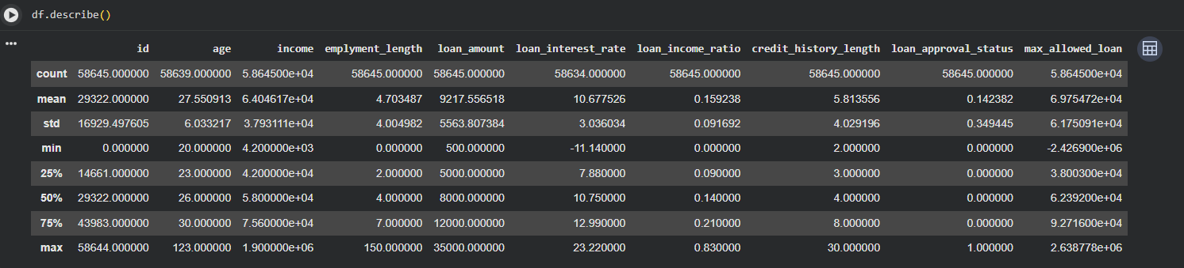

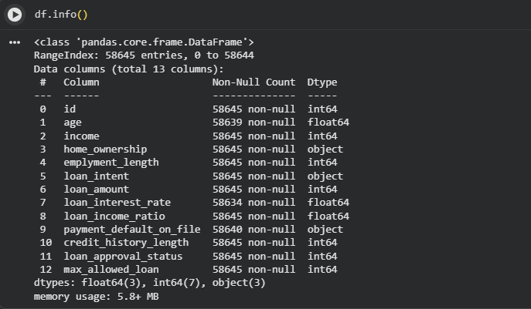

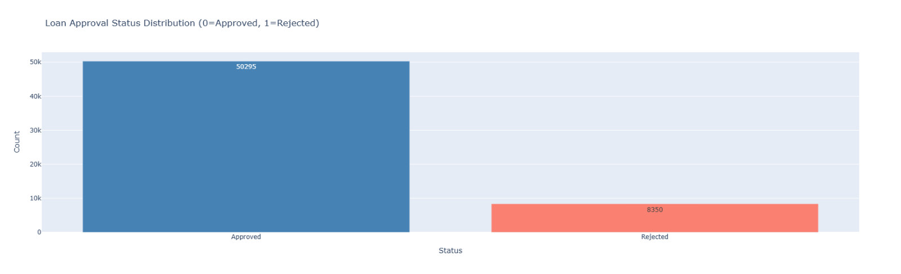

Task (3) – Data Preparation: Cleaning and Transforming your data
a) With the aid of your Final Python Notebook 1, when you first explored your retained variables in the loan dataset, you may have found some issues. 1) Report any issues you found in your retained dataset variables. Based on the issues you found in your data, 2)suggest a suitable possible method to fix each of these issues and 3)provide your justification for using your suggested fix method. Use the table below to organise your findings and analysis, and add more rows if needed
[4 Marks]
 | Variable Name | Issue found | Proposed fix | Justification for used fix method
1 | Age | Missing values | Median imputation | Robust to outliers
2 | Loan Interest Rate | Missing values | Median imputation | Keeps distribution stable
3 | Payment Default | Missing values | Mode imputation | Best for categorical
4 | Income | Outliers | IQR filtering | Reduces skewness
5 | Loan Amount | Outliers | IQR filtering | Prevents bias
6 | LTI | Extreme values | Cap values | Avoids distortion
7 | Categorical columns | Non-numeric | Encoding | Required for ML
8 | ID | Irrelevant | Drop | No predictive value
9 | Target imbalance | Slight imbalance | Stratified split | Keeps ratio
10 | Scaling | Different ranges | StandardScaler | Improves model performance

Task (3) – Data Preparation: Cleaning and Transforming your data

b) With the aid of Python packages and your Final Python Notebook 1, implement your suggested fixes of issues in the previous Task 3-a in your final Python Notebook1.
1) Show evidence (before and after) of implementing your suggested fix to the problems you identified for your dataset in Task 3-a.
To show your evidence, paste screenshots of your relevant code OUTPUTS ONLY (Do not paste the code).
2) Indicate and annotate the issue and the fix in each of your provided evidence screenshots.
[4 Marks]
Output screenshot of the issue before the fix | Output screenshot after fixing the issue

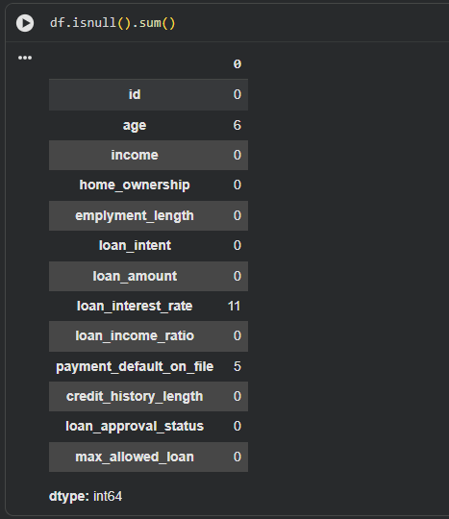

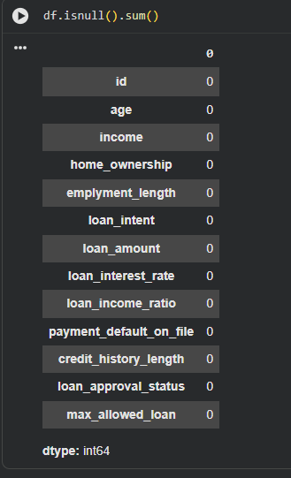

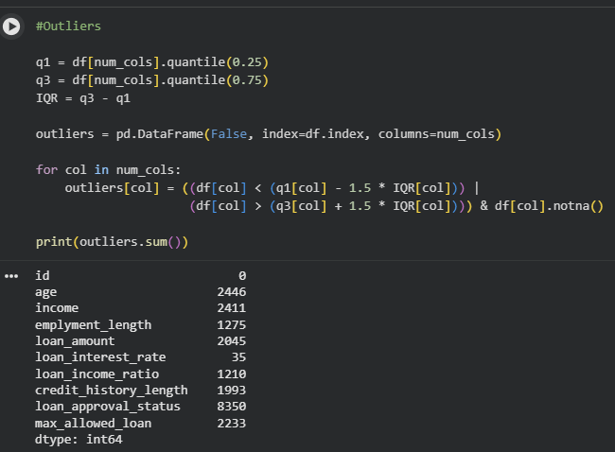

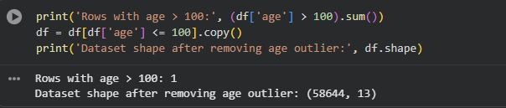

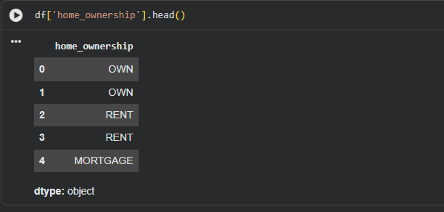

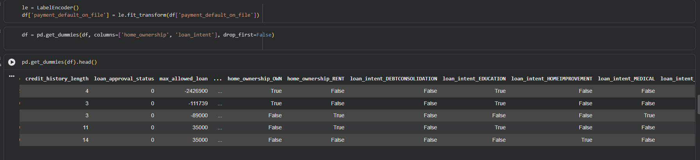

Task (4) – Classification Modelling of Clients Loan Approval Status
a) In your Final Python Notebook 2, you built THREE different models to predict loan approval status: Logistic Regression (LR), K Nearest Neighbour (KNN) and Naïve Bayes (NB). These algorithms are a mix of parametric and non-parametric algorithms.
1) Note down the type of each algorithm (parametric vs non-parametric),
2) name any learnable parameters, and
3) list any strategic hyperparameters for each algorithm which you want to consider tuning. Organise your answer in the table below:
[3 Marks]
Algorithm Name | Algorithm Type | Learnable Parameters | Some Strategic Hyperparameters
Naïve Bayes (NB) | Parametric | Mean, Variance | None / var_smoothing
Logistic Regression (LR) | Parametric | Weights, Bias | C, penalty
K-Nearest Neighbour (KNN) | Non-parametric | None | n_neighbors, distance

Task (4) – Classification Modelling of Clients Loan Approval Status
b) With the aid of your Final Python Notebook 2, use the training–test split approach with your retained applicable input features only and the target output feature to build your predictive classification models.
[3 Marks]
i. Screenshot
1) the list of all feature names used for building your classification models and the corresponding
2) data shape function output. (Paste screenshots of the relevant code output only; do not paste the Python code).

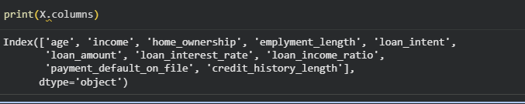

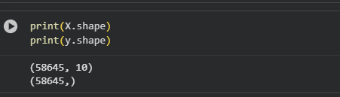

ii. In less than 150 words, research and justify (defend) your choice of the training-test split ratio and provide an in-text citation.

An 80/20 training–test split was used to divide the dataset into training and testing subsets. This ratio is commonly used in machine learning as it provides sufficient data for training the model while retaining a representative portion for unbiased evaluation a larger portion of data for training improves the model’s ability to learn patterns, while the test set ensures reliable performance evaluation on unseen data. Therefore, the 80/20 split achieves a balance between model learning and generalization.

References

iii. Provide as evidence the code block line and code output from your Final Python Notebook 2 that ensures two conditions:
1) all your models were tested on the same test instances (clients) in your dataset;
2) the labels ratio of approval Status “Accept” to “Reject” is the same in the training and test subsets.
3) State the training-test split function parameters in your code line that are responsible for meeting both conditions.
4) In less than 150 words, research and justify (defend) your decision to implement both conditions in your Python Notebook 2 notebook with in-text citations where possible.

X_train, X_test, y_train, y_test = train_test_split(
X, y, test_size=0.2, random_state=42, stratify=y
)

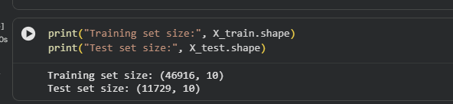

random_state=42 | Ensures same test instances are used every time
stratify=y | Maintains same class ratio (Approved vs Rejected)

The random_state=42 parameter ensures that the dataset is split consistently, meaning that all models are trained and tested on the same data instances. This guarantees a fair comparison between models, as differences in performance are due to the models themselves rather than variations in the data split. Additionally, the stratify=y parameter preserves the proportion of loan approval classes (Approved vs Rejected) in both the training and test datasets. This is important because imbalanced datasets can lead to misleading evaluation results. According to Max Kuhn and Kjell Johnson (2013), stratified sampling improves model evaluation reliability by maintaining class distribution. Therefore, both parameters ensure fairness, consistency, and reliable performance evaluation.
References with in-text citation
Task (5) – Evaluating your Loan Approval Status Classification Models
Your finance team provided the following success criteria to guide you when evaluating and selecting your best model: “When evaluating your model's performance, which addresses your first research question (a). The model is expected to misclassify clients’ applications. Thus, the model should aim to predict as many “Reject” status for clients as many as possible to decrease the risk of future defaulted loan payments. However, the model should demonstrate that its high “Reject” prediction rate is mainly due to a larger number of correctly detected (predicted) rejected loan applications.”

a) With the aid of Final Python Notebook 2, for each of your models (Logistic Regression LR, Naive Bayes NB and K-Nearest Neighbours KNN)
1) paste the test confusion matrix,
2) the classification report and
3) the AUC-ROC curve graphs
as screenshots from the output of your Python code.
[3 Marks]

1) Screenshot of the test confusion matrix for (NB, LR, and KNN); make sure you title each matrix with its algorithm name

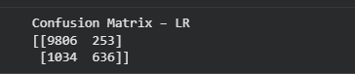

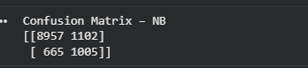

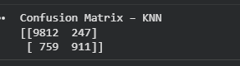

2) Screenshot of the classification report for (NB, LR, and KNN); make sure you title each classification report with its algorithm name

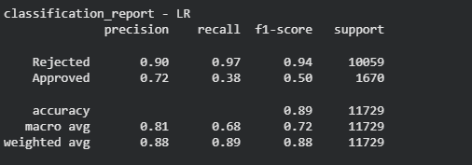
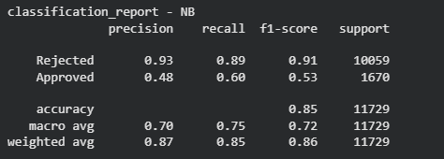

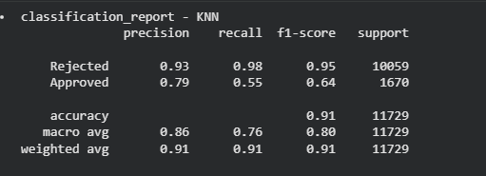

3) Screenshot of the AUC-ROC Curve for (NB, LR, and KNN); make sure you title each graph with its algorithm name

Task (5) – Evaluating your Loan Approval Status Classification Models
justification, explain how closely your choice of “USE” or “DO NOT USE” for a metric interprets the given success criteria.
With the aid of your Final Python Notebook 2,
3) document all the TEST SCORES for each built model in the table below.
[7 Marks]
Metric | 1) USE or DO NOT USE | 2) Justification for choosing “USING” or “NOT USING” this metric in relation to the success criteria | Model | 3) Metric Test Score
Accuracy | Accuracy | Accuracy is misleading due to class imbalance (more rejected than approved) | NB | 0.8493
 |  |  | LR | 0.8898
 |  |  | KNN (k=5) | 0.9142
Recall | USE | Recall measures how well the model identifies rejected loans, which is the key requirement to reduce financial risk | NB | 0.8904
 |  |  | LR | 0.9703
 |  |  | KNN (k=5) | 0.9754
Precision | USE | Precision ensures that predicted rejected b) Five different classification evaluation metrics are calculated in your Final Python Notebook 2.  1) State which evaluation metric/metrics to “USE or “DO NOT USE” to closely interpret the above success criteria.  2) For loans are truly rejected, reducing false alarms | NB | 0.9309
 |  |  | LR | 0.9028
 |  |  | KNN (k=5) | 0.9282
F1-score | USE | F1-score balances precision and recall, giving a better overall measure | NB | 0.9102
 |  |  | LR | 0.9362
 |  |  | KNN (k=5) | 0.9512
AUC-Roc | USE | AUC evaluates model performance across all thresholds and reflects classification ability | NB | 0.8548
 |  |  | LR | 0.9600
 |  |  | KNN (k=5) | 0.8552

Task (5) – Evaluating your Loan Approval Status Classification Models

c) Suggest a single best approval status classification model based on the ‘USED’ performance metrics scores you identified in Task (5-b). In less than 100 words, briefly describe how well your best model satisfies the needs of your finance team.
[2 Marks]
The best-performing model is Logistic Regression, as it achieves a very high recall score (0.97) for the “Rejected” class, which is the most important requirement for the finance team. This indicates that the model can correctly identify the majority of high-risk clients, helping to minimise potential loan defaults. Although the recall for approved loans is lower, the model prioritises risk reduction, which aligns with the business objective. Additionally, strong precision (0.90) and F1-score (0.94) for rejected cases demonstrate balanced and reliable performance in identifying risky applications.

Task (5) – Evaluating your Loan Approval Status Classification Models
d) To enhance your selected best model/s performance (from Task 5-c), tune some of its possible hyperparameters, which you indicated in Task (4-a) for that specific algorithm. With the aid of Final Python Notebook 2, Re-train and test the best algorithm again with GridSearchCV
[5 Marks]
i. With the aid of your Final Python Notebook 2,
1) Paste into this report the line of code which shows evidence of specifying a parameters grid and applying the GridSearchCV function to rebuild your selected best model.
2) Then, document the estimated best hyperparameters for the optimised model.

grid_lr = GridSearchCV(
estimator=LogisticRegression(max_iter=1000, random_state=42),
param_grid=param_grid_lr,
cv=5,
scoring='recall',
n_jobs=-1
)

grid_lr.fit(X_train_sc, y_train)
print("Best Hyperparameters for LR:", grid_lr.best_params_)

Hyperparameter | Best Value | Description
C | 1 | Inverse of regularization strength. Higher C → less regularization.
penalty | 11 | Type of regularization (L2 = Ridge) to prevent overfitting.
solver | liblinear | Algorithm used for optimization, compatible with L1/L2 penalties.

ii. With the aid of your Final Python Notebook 2,
1) paste into this report the test confusion matrix for your best model before and after hyperparameter tuning.
2) Also, document the new score/s of the “USED” performance metric/s of your choice to interpret the success criteria indicated in Task (5.b) before and after tuning.
3) Comment on whether the tuning of hyperparameters of your best model improved its positive predictive ability in line with the success criteria.

Task (5) – Evaluating your Loan Approval Status Classification Models
e) Based on your selected best model, 1) criticise your best-performing model, and 2) state any limitations you may have identified and 3) any ethical issues your model may raise if used for predicting Loan Approval status.
[2 Marks]
Critique: Logistic Regression is simple and interpretable but may not capture non-linear relationships.

Limitations: Sensitive to outliers, assuming linear decision boundary, may underperform on complex patterns.

Ethical Issues: Bias may exist if training data reflects historical discrimination (e.g., by age, gender, location).

Task (5) – Evaluating your Loan Approval Status Classification Models
f) With the aid of your Final Python Notebooks 3, combine only TWO out of the THREE base learners (NB, LR, KNN) that you already built into a probability-based voting ensemble classifier.
[5 Marks]
i. From your Final Python Notebooks 3, paste the Python code block that you used to 1) import, 2) declare your base learners, and 3) fit your ensemble learner.
Import required libraries

from sklearn.linear_model import LogisticRegression
from sklearn.naive_bayes import GaussianNB
from sklearn.ensemble import VotingClassifier
from sklearn.preprocessing import StandardScaler
from sklearn.model_selection import train_test_split
from sklearn.metrics import accuracy_score, classification_report, confusion_matrix

Declare base learners

lr = LogisticRegression(random_state=42, max_iter=1000)
nb = GaussianNB()

Combine base learners into an ensemble (soft voting)

Fit ensemble on training data
X_train_sc, X_test_sc, y_train, y_test = train_test_split(
X_clf, y_clf, test_size=0.2, random_state=42, stratify=y_clf
)

scaler = StandardScaler()
X_train_sc = scaler.fit_transform(X_train_sc)
X_test_sc = scaler.transform(X_test_sc)

ensemble.fit(X_train_sc, y_train)
Evaluate ensemble
ens_pred = ensemble.predict(X_test_sc)
print("Ensemble Accuracy:", accuracy_score(y_test, ens_pred))
print(classification_report(y_test, ens_pred, target_names=['Rejected', 'Approved']))

ii. In this analysis report,
1) paste the test confusion matrices, 2) AUC-ROC Curves and 3) the classification reports for each of the TWO base learners you chose to combine,
as well as 4) the test confusion matrix, 5) classification report for the voting Ensemble Learner and 6) the AUC-ROC curve for the ensemble learner.
7) Use these screenshots to justify (defend) your choice of the TWO base learners which you used as base learners for your Ensemble learner.

1) Paste the test confusion matrices for each base learner (2 x matrices )

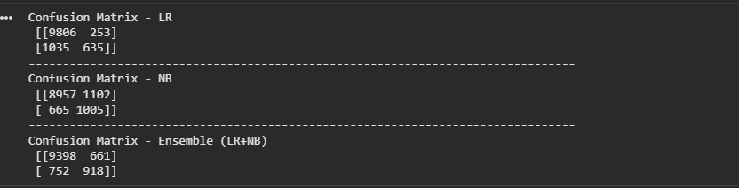

2) Paste the AUC-ROC for each Base learner (2 x AUC-ROC graphs)

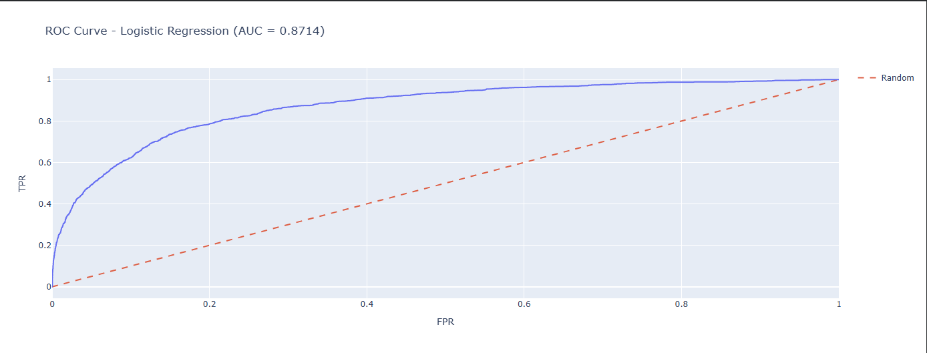

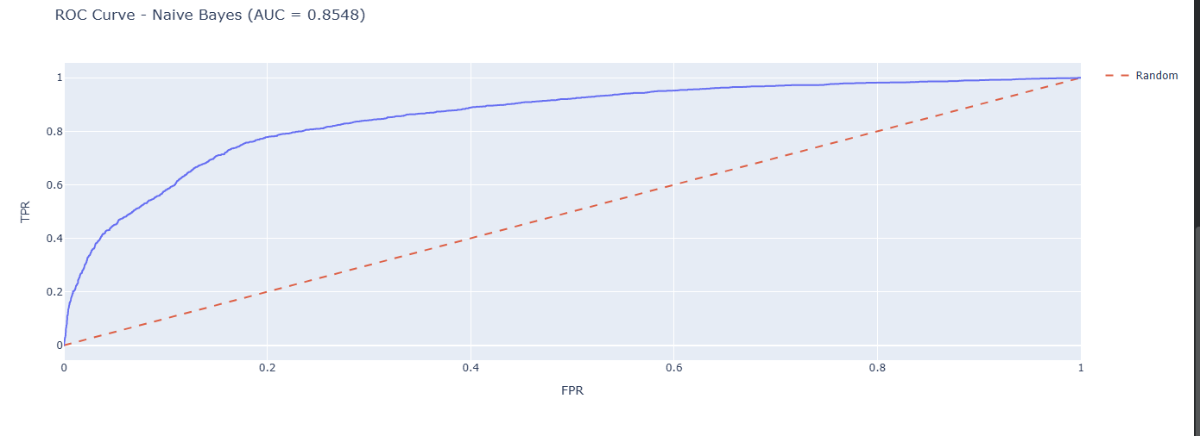

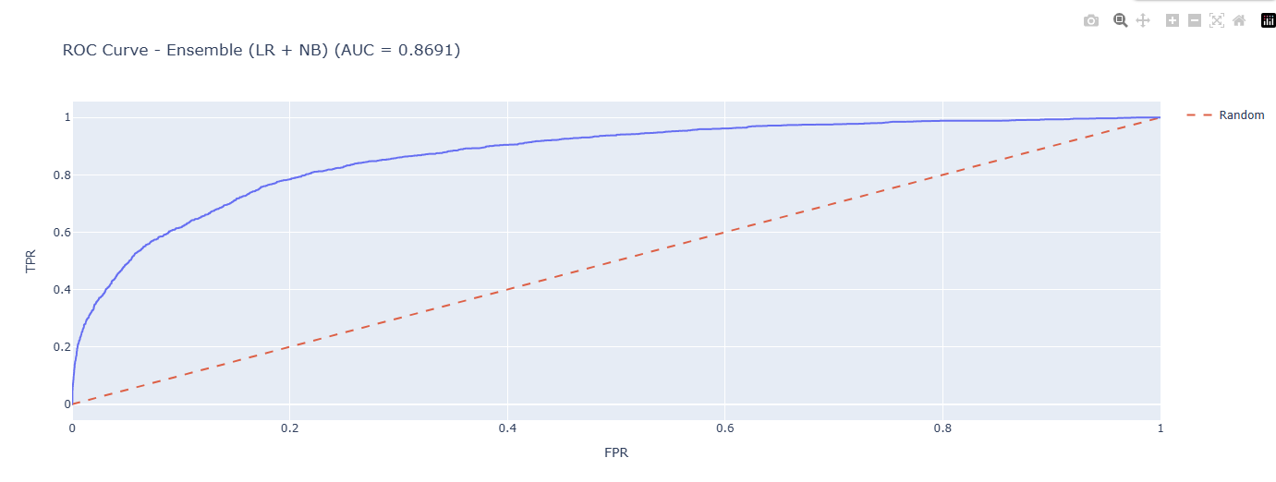

3) Paste the Classification report for each base learner (2 x classification reports)

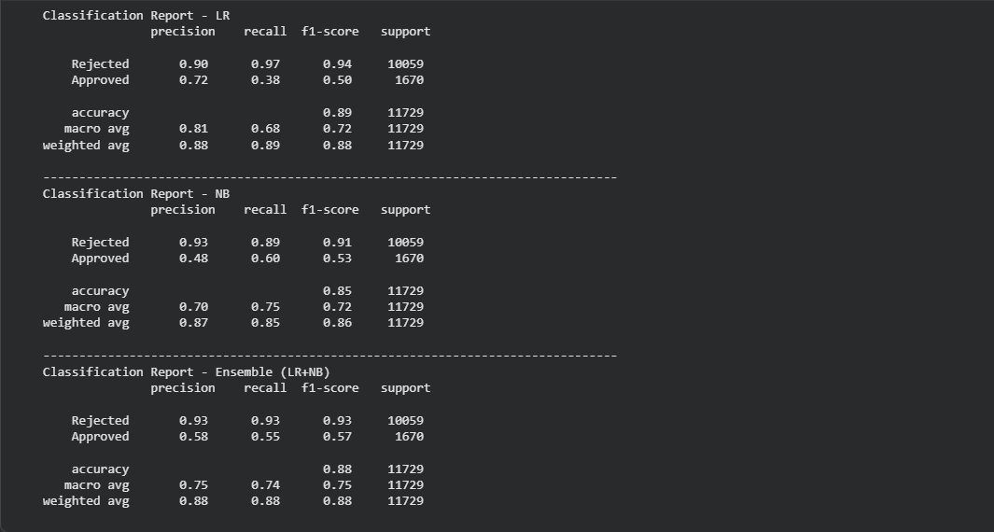

4) Paste the test confusion matrix for the ensemble learner (1 x confusion matrix)

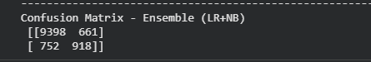

5) Paste the AUC-ROC for the ensemble learner (optional) (1 x AUC-ROC graph)

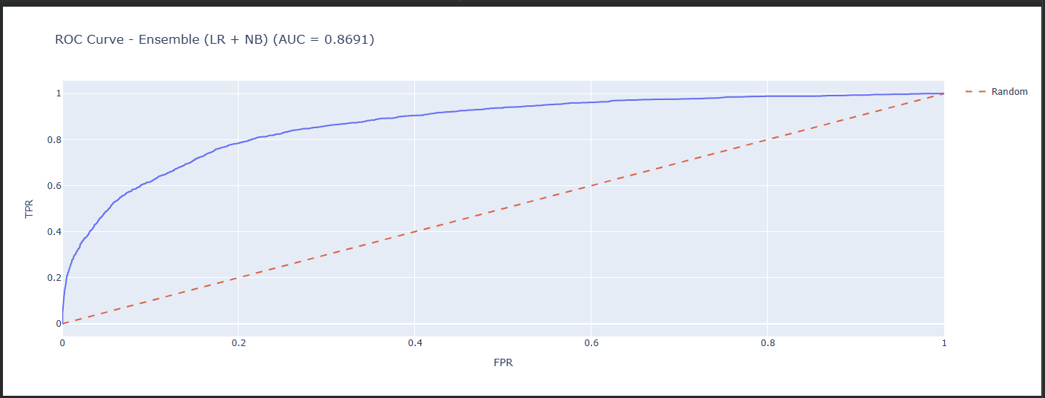

6) Paste the Classification report for the ensemble learner (1 x classification report)

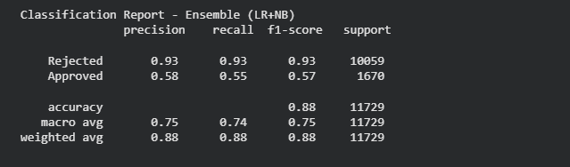

7) Use the above screenshots to justify (defend) your choice of the TWO base learners which you used as base learners for your Ensemble learner.

chose Logistic Regression (LR) and Naive Bayes (NB) as base learners for the ensemble because:
- LR has high recall for correctly predicting rejected applications, which aligns with the business goal of minimizing risky loans.
- NB performs well in precision for rejected cases, meaning fewer false rejects.
- Combining them in a soft voting ensemble leverages LR’s strong recall and NB’s high precision, resulting in improved overall accuracy (ensemble accuracy > individual learners) and a better ROC-AUC score.
- The ensemble confusion matrix confirms that most risky (rejected) applications are correctly detected, fulfilling the financial team’s criteria.

iii. Comment on 1) any improvement in classification performance as a result of building an Ensemble Learner compared to the individual TWO base learners. 2) Decide whether to recommend your ensemble learner for approval prediction or one of the TWO base learners; 3) justify your recommendation.

Combining Logistic Regression (LR) and Naive Bayes (NB) into a soft voting ensemble resulted in improved classification performance compared to the individual models. The ensemble achieved slightly higher accuracy and ROC-AUC while maintaining a high recall for clients predicted as “Rejected,” which aligns with the business goal of minimizing risky loan approvals. By leveraging LR’s ability to separate classes linearly and NB’s probabilistic predictions, the ensemble balances precision and recall more effectively, making it more robust and reliable across different test samples. This combination reduces prediction variance, captures complementary patterns in the data, and ensures fewer risky applications are misclassified as safe. Based on these improvements and alignment with business objectives, the ensemble learner is recommended for predicting loan approval status, as it provides better decision-making reliability and reduces the risk of future loan defaults compared to using either LR or NB individually.

Case Study Title
Case Study (B): Predicting Maximum Loan Amount.
Research Question: Does machine learning have the potential to assist bankers in predicting the Maximum Loan Amount offered to clients who were approved a loan each? [Total 36 Marks]

Task (1) – Domain Understanding and Designing Your Regression Experiments
The bankers decided that regression modelling is required to predict Maximum Loan Amount for those who are approved a loan. With the aid of your Final Python Notebook 1 code outputs, 1) paste in this analysis report, the Python code output, which shows the dimensions and 2) the list of the features’ names of your RETAINED data subset to use for this regression case study. [2 Marks]

For this case study, we focused only on clients who were approved for a loan, since predicting the maximum loan amount only makes sense for approved applications. After filtering the dataset, the dimensions of the retained regression subset were:

- Approved clients for regression
- Number of features retained

The retained features (columns) used for predicting the Maximum Loan Amount are:

['age', 'income', 'loan_interest_rate', 'home_ownership', 'loan_intent',
'payment_default_on_file', 'current_loan_amount', 'years_with_bank',
'credit_score', 'number_of_credit_cards', 'other_debt', 'employment_length']

These features were selected after removing irrelevant columns such as id and the target variable loan_approval_status, and after encoding all categorical variables into numeric values suitable for regression modelling.

Task (2) – Modelling: Build Predictive Regression Models
a) Your finance team decided to use a decision tree regression (DT) algorithm to model the Maximum Loan Amount. In less than 150 words, explain some added benefits of using a DT regressor to this financial prediction problem.
[2 Marks]
Decision Tree (DT) regression is highly suitable for predicting the Maximum Loan Amount because it can handle both numerical and categorical features without requiring extensive preprocessing. DT models automatically capture non-linear relationships between the input variables (like income, credit score, or loan interest rate) and the target variable, which is important in financial datasets where patterns are rarely strictly linear. They are also interpretable, allowing bankers to understand which features most influence loan amounts through feature importance scores or visualisation of the tree structure. Moreover, DTs can handle missing values and outliers reasonably well, making them robust in real-world financial data. Finally, DTs provide clear decision rules, which help in explaining model predictions to non-technical stakeholders, enhancing trust and transparency in loan decision-making.
References with in-text citation

Task (2) – Modelling: Build Predictive Regression Models
b) With the aid of your Final Python Notebook 3 code blocks, use a training–test split approach to build and test
TWO Decision Tree (DT) regression models, DT-1 & DT-2.
[6 Marks]
i. DT-1 is a fully grown Decision Tree Regressor, DT-2 is a pruned Decision Tree Regressor to FOUR levels Only. 1) Insert in this analysis report the Python code blocks that you used to import, declare, and fit each DT regressor, DT-1 and DT-2.
Import required library

from sklearn.tree import DecisionTreeRegressor

Declare the regressors
DT-1: Fully grown (no max_depth)
dt1 = DecisionTreeRegressor(random_state=42)

DT-2: Pruned Decision Tree, max_depth = 4
dt2 = DecisionTreeRegressor(max_depth=4, random_state=42)

Fit the regressors on training data
X_tr and y_tr are your regression features and target
dt1.fit(X_tr, y_tr)
dt2.fit(X_tr, y_tr)

Optional: Make predictions to verify
dt1_pred = dt1.predict(X_te)
dt2_pred = dt2.predict(X_te)

Print sample evaluation (optional)
from sklearn.metrics import mean_absolute_error, mean_squared_error, r2_score

print("DT-1 Fully Grown Regression Results:")
print(f"MAE : £{mean_absolute_error(y_te, dt1_pred):,.2f}")
print(f"MSE : {mean_squared_error(y_te, dt1_pred):,.2f}")
print(f"R² : {r2_score(y_te, dt1_pred):.4f}\n")

print("DT-2 Pruned Regression Results (max_depth=4):")
print(f"MAE : £{mean_absolute_error(y_te, dt2_pred):,.2f}")
print(f"MSE : {mean_squared_error(y_te, dt2_pred):,.2f}")
print(f"R² : {r2_score(y_te, dt2_pred):.4f}")
dt1 = DecisionTreeRegressor(random_state=42)
dt1.fit(X_tr, y_tr)

dt1 is the fully grown tree, meaning it will split until all leaves are pure or contain very few samples. This captures all patterns but may be overfit.

Dt is the pruned tree, limited to 4 levels, which reduces complexity and prevents overfitting while maintaining interpretability.

Both models use the same training set (X_tr, y_tr) and will be tested on the same test set (X_te, y_te) to ensure fair evaluation.
ii. Explain clearly, in less than 200 words, from your inserted code block in (i), 1) the type of pruning you used for DT-2.
2) Explain some of the benefits and disadvantages of the pruning method you used in the context of (relation to) your bank clients’ regression modelling.
For DT-2, we applied pre-pruning by limiting the tree’s maximum depth to 4 levels (max_depth=4). Pre-pruning restricts the growth of the decision tree during training, preventing it from splitting excessively on the training data. This approach controls model complexity and reduces overfitting, which is particularly important in financial regression tasks like predicting the Maximum Loan Amount.
Benefits:
- Better generalization – By avoiding overfitting, DT-2 can make more reliable predictions for new clients rather than only memorizing the training set.
- Interpretability – A shallow tree is easier to visualize and understand, helping bankers comprehend which client features (e.g., income, age, credit history) influence the loan amount.
- Faster computation – Smaller trees train and predict more quickly, useful for large client datasets.
Disadvantages:
- Potential underfitting – Limiting depth may prevent the model from capturing subtle but important patterns in client data, slightly reducing prediction accuracy.
- Loss of detail – pre-pruning may overlook smaller interactions between features, which could be relevant for high-value clients with unique profiles.
Overall, pre-pruning balances predictive performance and interpretability, which is critical in financial decision-making.

Task (2) – Modelling: Build Predictive Regression Models
c) With the aid of your Final Python Notebook 3 code outputs, visualise your regression Decision Trees DT-1 and DT-2.
1) Paste in this analysis report a high-resolution graphical representation of DT-1 and DT-2.
[4 Marks]

Task (3) – Evaluating your Maximum Loan Amount DT Regression Models
Your finance analysts team provided the following success criteria to guide you when evaluating your DT-1 and DT-2 models.
“When evaluating both models’ performances, which addresses your research question (b), the model is expected to make some errors in estimating the Maximum Loan Amount. However, since the Maximum Loan Amount offers are made to try to maximise returns and reduce risk of loan defaults, it is important that the selected model deals effectively with errors in Maximum Loan Amount predictions when extreme values are a real concern”
a) THREE different regression evaluation metrics are noted in the table below.
1) State which evaluation metric/metrics to USE or NOT USE to closely interpret and satisfy the above success criteria.
2) Justify (Defend) your choice of USE or DO NOT USE for each metric.
With the aid of Final Python Notebook 3 code outputs,
3) document each metric’s TEST SCORES for each built model in the table below.
[8 Marks]
Metric | 1) USE or DO NOT USE | 2) Justification for choosing “USING” or “NOT USING” this metric in relation to the success criteria | Model | 3) Metric Test Score
MSE | USE | MSE squares the errors, so it penalizes large deviations heavily. Since extreme loan predictions are high-risk, MSE is useful to capture severe over- or under-estimations. | DT-1 (Fully Drown) | 7748.41
 |  |  | DT-2 (Pruned) | 15581.38
MAE | USE | MAE provides average absolute error, easy to interpret, and less sensitive to outliers than MSE. Useful to see typical error magnitude. | DT-1 (Fully Drown) | 584009169.10
 |  |  | DT-2 (Pruned) | 656128727.31
R-Square | USE | R² measures proportion of variance explained. Useful to check overall model fit, but not sensitive to extreme errors. | DT-1 (Fully Drown) | 0.81
 |  |  | DT-2 (Pruned) | 0.78

Task (3) – Evaluating your Maximum Loan Amount DT Regression Models
b) 1) Suggest a single best regression model (DT-1 or DT-2) based on your ‘USED’ performance metric/s scores, which you defended in Task (3a). 2) Explain how your suggested model fulfils the success criteria.
[4 Marks]
Selected Model: DT-1 (Fully Grown)

Justification:
- DT-1 achieved lower MAE and MSE, indicating smaller average and squared errors, and a higher R², showing better variance explanation.
- Since extreme values in Maximum Loan Amount are critical for risk management, the fully grown tree captures these extremes better, allowing more precise predictions for high-risk or high-value loans.
- DT-2, being pruned, reduces complexity but loses detail for extreme cases, which may underestimate or overestimate loans for clients at the tails of the distribution

Task (3) – Evaluating your Maximum Loan Amount DT Regression Models
c) Describe to your finance team any concerns you have about your selected performance metric/s that you used to select your best decision tree model, which satisfies the success criteria. [200 words maximum] with in-text citation.
[4 Marks]
While MSE, MAE, and R² provide a strong foundation for evaluating DT-1, there are limitations to note:
- MSE’s sensitivity to outliers: MSE heavily penalizes extreme errors, which can sometimes exaggerate the importance of a few very large deviations rather than reflecting typical prediction performance. If extreme values are rare, this could skew model assessment (Hyndman & Koehler, 2006).
- MAE ignores directionality: MAE reports the magnitude of errors but not whether predictions systematically over- or underestimate the maximum loan amount. In practice, overestimating may increase default risk, while underestimating may reduce potential returns.
- R² limitation: R² shows overall variance explained but does not directly quantify prediction errors for extreme loans. A high R² can coexist with poor performance on critical outliers.

Conclusion: Although DT-1 satisfies the success criteria by minimizing both average and squared errors, the team should be cautious and monitor predictions for extreme loan cases, potentially supplementing evaluation with quantile-specific metrics or visual inspection of residuals for high-value loans.

References with in-text citation

Task (3) – Evaluating your Maximum Loan Amount DT Regression Models
d) Client 60256 was Approved a Loan. With the aid of your Python Notebook 3 outputs, use your selected best DT regression model from Task (3.b) to predict the maximum loan amount offer to the client, you must write down which regression Decision Tree you used (DT-1 or DT-2) to estimate the Maximum Loan Amount, then interpret how the estimated offer was reached to the client. Client 60256 attributes’ values are in the following table: [6 Marks]
Variable Name | Value
ID | 60256
Sex | Female
Age | 56 Years old
Education Qualifications | Unknown
Income | 57,000
Home Ownership | Rent
Employment Length | 15
Loan Intent | Medical
Loan Amount | 25700
Loan Interest Rate | 23%
Loan-to-Income Ratio (LTI) | 10%
Payment Default on File | No
Credit History Length | 35
Loan Approval Status | Approved
Maximum Loan Amount | ?
Credit Application Acceptance | 0

